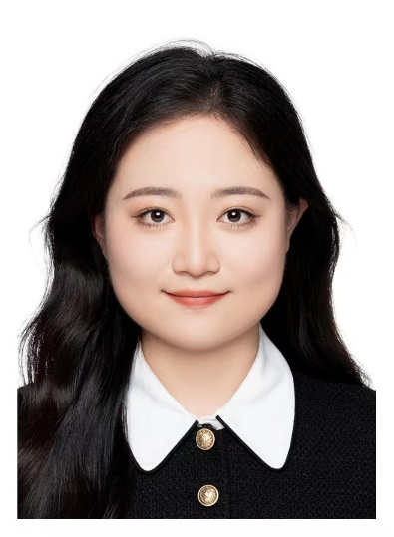Yan Yi

Research Assistant(2023.Oct-)

M.A,Tsinghua University

B.E,Zhongnan University of Economics and Low

M.Arch, University College London

B.Arch, Southwest Jiaotong University

B.Eng.Xi'an University of Science and Technology

M.Eng. Hunan University

WU Junyuan

MPhil student (2023.Sep-)

M.S, University of Edinburgh

B.Eng, South China University of Technology

 Zhou Bingling

Visiting Student(2023.Nov-)

M.E,Hunan University

B.Eng.,Wuhan University of Technology

B.Eng ,Central South University